11. BOUNDARY LAYER THEORY
EXTERNAL FLOW
BOUNDARY LAYER THEORY | FLOW OVER SUBMERGE BODY
As we go away from the wall the shear stress decreases because of increasing the slope of velocity profile.
- When a real fluid flows and Passes a solid boundary, viscous effects get concentrated in a very thin region adjacent to the surface.  - The flow in this thin region is known as boundary layer flow. (Real, Rotational, No slip condition)  - The flow beyond the boundary layer. (Ideal, Irrotational, with almost uniform velocity profile.) | 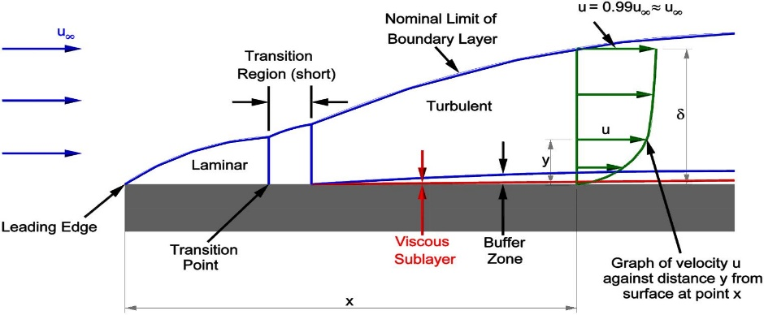
BOUNDARY LAYER THEORY ON FLAT PLATES:
$U_{∞}=$ Free stream Velocity | $x=0=$Leading Edge |  | $x=L=$Trailing Edge
$u=$ Local Velocity | $B=$ Width of the plate
$δ=$ Boundary Layer/ Nom. thickness | $x=$ Dist. Measured Along the plate from LE
$${Re}_{x}=\frac{ρU_{∞}x}{μ}=\frac{U_{∞}x}{ϑ}$$ |  | $${Re}_{L}=\frac{ρU_{∞}L}{μ}=\frac{U_{∞}L}{ϑ}$$

CLASSIFICATION OF FLOW INSIDE BOUNDARY LAYER
LAMINAR | TRANSITIONAL |  | TURBULENT
 | HLBL | LTBL
$${Re}_{x}≤2*{10}^{5}$$ | $${Re}_{x}≤5*{10}^{5}$$ | $${Re}_{x}>5*{10}^{5}$$ | $${Re}_{x}>6*{10}^{5}$$
LAMINAR BOUNDARY LAYER (LBL):
- BOUNDARY LAYER THICKNESS/ NOMINAL THICKNESS ($δ$):
The distance measured perpendicular or normal from the wall of a plate till the point velocity is almost $U_{∞}$.
$$\frac{δ}{x}=\frac{K}{\sqrt{{Re}_{x}}}, Where K= Constant$$ | - K Depends on the velocity profile inside the BL  - $K=5$ (if not given)
- VELOCITY PROFILE:
EXACT VELOCITY PROFILE | APPROXIMATE VELOCITY PROFILE
Blasius Velocity profile. | E.g. Linear, Parabolic, Cubic, sinusoidal Velocity Profile
$K=5$ (Blasius Constant) | $$Linear VP:\frac{u}{U_{∞}}=\frac{y}{δ},K=3.46$$ | $$Sinusoidal VP:\frac{u}{U_{∞}}=\sin\left(\frac{π}{2}\frac{y}{δ}\right),K=4.79$$
- WALL SHEAR STRESS ($τ_{0}$):
$$Friction Coeff.=\frac{Wall Shear Stress}{Dynamic Pressure}=\frac{τ_{0}}{\frac{1}{2}ρU_{∞}^{2}}=C_{f}=Local Skin Friction$$ | In LBL,$C_{f}={\left({Re}_{x}\right)}^{-0.5}$  $$∴τ_{0}∝{\left(x\right)}^{-0.5}$$

CASE-I: Exact Velocity Profile | CASE-II: Approximate Velocity Profile
$$C_{f}=\frac{0.664}{\sqrt{{Re}_{x}}}⇒τ_{0}=\frac{0.664}{\sqrt{{Re}_{x}}}*\frac{1}{2}ρU_{∞}^{2}$$ | $$τ_{0}=μ{\left.\frac{du}{dy}\right|}_{y=0}$$
- DRAG FORCE ($F_{D}$):
$$F_{D}=\int{dF_{D}}=\int{τ_{0}}dA=B\int{τ_{0}}dx=Drag force on one side of the plate$$ | 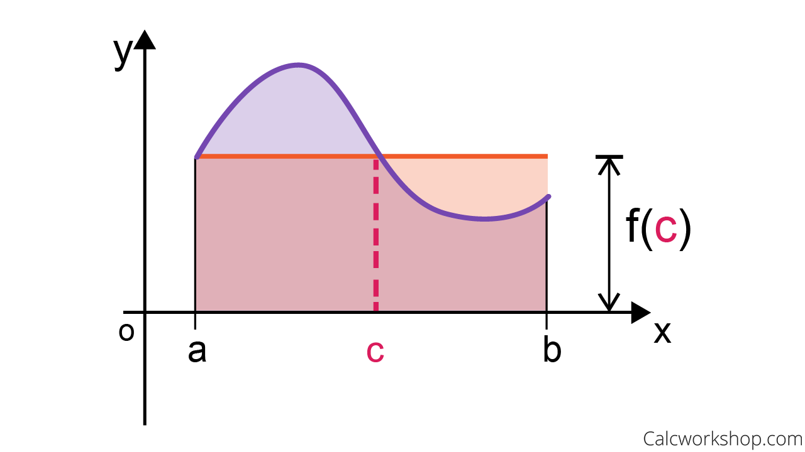  $$C_{D}=\frac{1}{L}\int{C_{f}*dx}$$
$$F_{D}=B\int{C_{f}*\frac{1}{2}ρU_{∞}^{2}dx}=\frac{B}{2}ρU_{∞}^{2}\int_{0}^{L}{C_{f}*dx}=\frac{1}{2}ρU_{∞}^{2}C_{D}(LB)(1 Side of Plate)$$
$\overline{C_{f}}=$ Average Skin Friction $=C_{D}=$ Coefficient of drag.
SUMMARY
$$\frac{δ}{x}=\frac{K}{\sqrt{{Re}_{x}}}$$ | $$\frac{τ_{0}}{\frac{1}{2}ρU_{∞}^{2}}=C_{f}∝\frac{1}{\sqrt{{Re}_{x}}}$$ | $$τ_{0}=C_{f}\frac{1}{2}ρU_{∞}^{2}= μ{\left.\frac{du}{dy}\right|}_{y=0}$$ | $$C_{f}=\frac{0.664}{\sqrt{{Re}_{x}}}$$
$$F_{D}=\int{τ_{0}}dA=\frac{1}{2}ρU_{∞}^{2}C_{D}(LB)$$ |  | $$C_{D}=\frac{1}{L}\int_{0}^{L}{C_{f}*dx}$$
TURBULENT BOUNDARY LAYERS ON FLAT PLATES: ${Re}_{x}>5*{10}^{5}$
- BOUNDARY LAYER THICKNESS/ NOMINAL THICKNESS ($δ$):
$$δ=\frac{0.371x}{{\left({Re}_{x}\right)}^{1/5}} ∝x^{4/5}$$ | NOTE: Turbulent Boundary layer grows faster along a plate compared to laminar boundary layer.
- VELOCITY PROFILE:
$$n^{th}POWER LAW: \frac{u}{U_{∞}}={\left(\frac{y}{δ}\right)}^{1/n}$$ | Std. Value, $n=7$
- WALL SHEAR STRESS ($τ_{0}$):
$$τ_{0}=C_{f}\frac{1}{2}ρU_{∞}^{2}$$ | $$C_{f}=\frac{0.0579}{{\left({Re}_{x}\right)}^{1/5}} (For 7^{th} Power Law)$$
- DRAG FORCE ($F_{D}$):
$$F_{D}=\frac{1}{2}ρU_{∞}^{2}C_{D}A, Where A=BL$$ | $$C_{D}=\frac{0.072}{{\left({Re}_{x}\right)}^{1/5}}$$  $$(For 5*{10}^{5}≤{Re}_{x}≤{10}^{7})$$ | $$C_{D}=\frac{0.455}{{\left(\log_{10}{{Re}_{x}}\right)}^{2.58}}$$  $$(For {10}^{7}≤{Re}_{x}≤{10}^{9})$$
BOUNDARY CONDITIONS:
- No Slip Condition: At $y=0,u=0⇒τ={du}/{dy}=0$
- Definition of Boundary Layer: At $y=δ,u≈U_{∞}⇒τ={du}/{dy}=0$
- No Variation in velocity outside boundary Layer: At $y≥δ,u≈U_{∞}⇒τ={du}/{dy}=0$
- Linear Velocity Profile or Constant shear stress neat to the surface:
At $y≈0,τ={du}/{dy}=C⇒{dτ}/{dy}={d^{2}u}/{dy^{2}}=0$
- At $y=δ,u≈U_{∞}⇒{dτ}/{dy}={d^{2}u}/{dy^{2}}=0$
Note: Boundary Conditions must be used in same sequence as given because initial boundary conditions are more fundamental in nature.
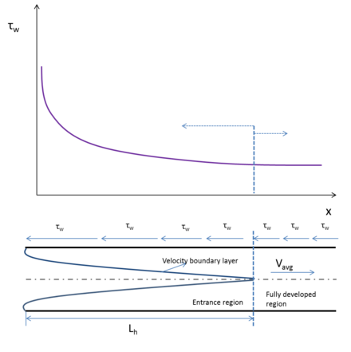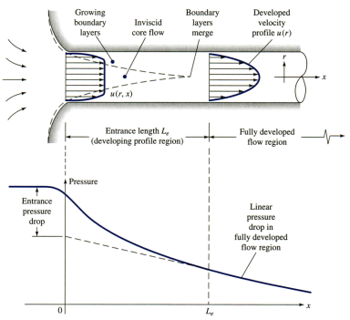 | DEVELOPMENT OF FLOW:  As shown in the graphs,  - Wall shear stress decreases during entrance length. And in the turbulent region wall shear stress remains constant.  - Pressure or Head decreases throughout the length of the pipe. And in the turbulent region Pressure dopes linearly decreasing.  - $u_{max}$ increasing in the entrance length and it remains maximum in the turbulent region.  In the turbulent region,  $$u_{max}=2u_{avg}=2U_{∞}$$  Entrance Length  Max. for Laminar Min. for Turbulent
DISPLACEMENT THICKNESS ($δ^{*}$): The distance measured perpendicular or normal to the wall, by which a stream line following adjacent to boundary layer gets displaced in order to compensate reduced mass flux.
${\dot{m}}_{1}=$ Issued Mass Flux,  ${\dot{m}}_{2}=$ Mass Flux Allowed to Flow through BL,  ${\dot{m}}_{3}=$ Mass Flux Reduced/ Not Allowed to Flow through BL,  From continuity equation, ${\dot{m}}_{3}={\dot{m}}_{1}-{\dot{m}}_{2}$  $$\left(δ^{*}B\right)U_{∞}=\int_{0}^{δ}{U_{∞}B dy}-\int_{0}^{δ}{uB dy}=\int_{0}^{δ}{B(U_{∞}-u) dy}$$  $$δ^{*}=\int_{0}^{δ}{\left(1-\frac{u}{U_{∞}}\right) dy}$$ | 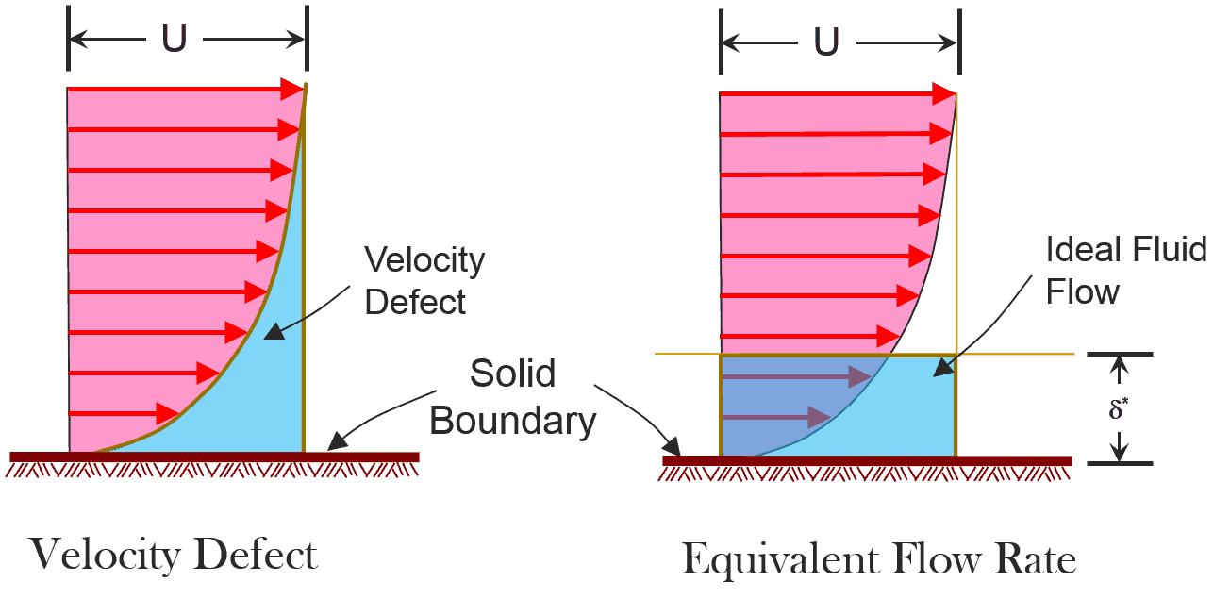
Note: For power law profile, $δ^{*}=δ/{\left(n+1\right)}$
CONCLUSION: | - $δ^{*}<δ$ | - For linear Velocity profile, $δ^{*}=0.5 δ$
Alternative Definition of $δ^{*}$: The distance measured perpendicular to the surface by which the surface should be displaced to compensate the reduction in mass flux inside the boundary layer.

MOMENTUM THICKNESS ($Θ$): It’s the distance measured perpendicular or normal to the wall of a plate by which it should be displaced in order to compensate the reduction in momentum flux inside the boundary layer.
$$Θ=\int_{0}^{δ}{\frac{u}{U_{∞}}\left(1-\frac{u}{U_{∞}}\right) dy}$$ |  | $$SHAPE FACTOR =H=\frac{δ^{*}}{Θ} (Always>1)$$
For LBL, $H ϵ \left(2.5-3\right)$ | For Blasius Velocity Profile $H=2.59$ |  | For TBL, $H ϵ \left(1.3-1.4\right)$
NOTE: Higher the shape factor, higher the chances of adverse pressure gradient. Therefore, higher chances of boundary layer separation.
KARMAN MOMENTUM INTEGRAL EQUATION:
$${\dot{m}}_{AB}=\int_{0}^{δ}{ρudy}$$ $${\dot{m}}_{CD}={\dot{m}}_{AB}+\frac{∂{\dot{m}}_{AB}}{∂x}dx=\int_{0}^{δ}{ρudy}+\frac{∂}{∂x}\int_{0}^{δ}{ρudydx}$$  From Continuity equation, ${\dot{m}}_{BC}={\dot{m}}_{CD}-{\dot{m}}_{AB}=\frac{∂}{∂x}\int_{0}^{δ}{ρudydx}$  $${\left(\dot{m}V\right)}_{AB}=\int_{0}^{δ}{ρu^{2}dy}$$ $${\left(\dot{m}V\right)}_{CD}=\int_{0}^{δ}{ρu^{2}dy}+\frac{∂}{∂x}\int_{0}^{δ}{ρu^{2}dy}dx$$  $${\left(\dot{m}V\right)}_{BC}=\frac{∂}{∂x}\int_{0}^{δ}{ρudydx}U_{∞}$$ | 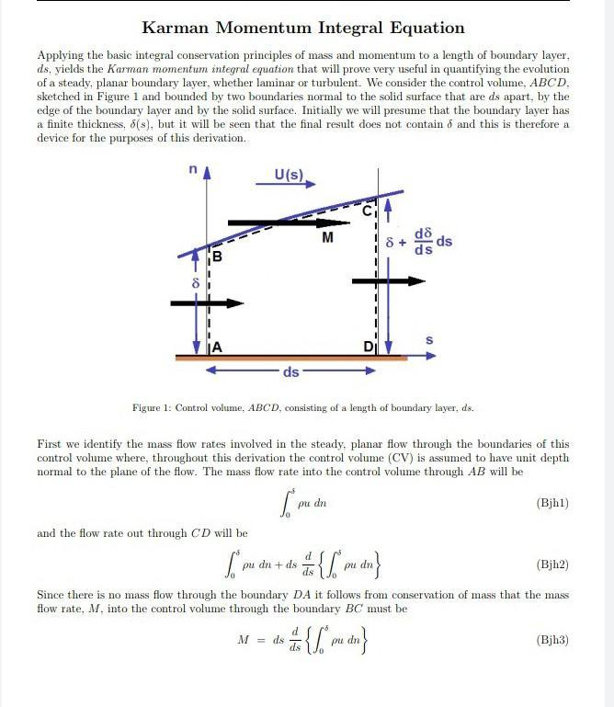
From Momentum Equation,
$$\sum{F_{x}}=-τ_{0}dx=∆{\left(\dot{m}V\right)}_{x}={\left(\dot{m}V\right)}_{CD}-{\left(\dot{m}V\right)}_{AB}-{\left(\dot{m}V\right)}_{BC}=\frac{∂}{∂x}\int_{0}^{δ}{ρ\left(u^{2}-uU_{∞}\right)dydx}$$
$$\frac{τ_{0}}{ρU_{∞}^{2}}=ρ\frac{∂}{∂x}\int_{0}^{δ}{\left(\frac{u}{U_{∞}}-\frac{u^{2}}{U_{∞}^{2}}\right)dy}=\frac{∂Θ}{∂x}=\frac{1}{2}C_{f}(Karman Momentum Integral Equation)$$
ASSUMPTIONS IN DERIVATION:
The flow is incompressible. | Applicable for 2D flow. | $${dP}/{dx}=0$$
ENERGY THICKNESS $\left(δ_{E} or δ^{**}\right)$: The distance measured perpendicular or normal to the wall of a plate by which it should be displaced in order to compensate the reduction in kinetic energy flux.
$$δ_{E}=\int_{0}^{δ}{\frac{u}{U_{∞}}\left[1-{\left(\frac{u}{U_{∞}}\right)}^{2}\right] dy}$$ | For Linear Velocity Profile,  $$δ^{*}=δ/2$$ $$Θ=δ/6$$ $$H=3$$ $$δ_{E}=δ/4$$
BOUNDARY LAYER SEPARATION:
Forces Consideration in the Boundary layer Separation,
$F_{I}=$ Inertia Force | $F_{V}=$ Viscous Force | $F_{P}=$ Pressure Force
Conditions in the flows,
1 | $$\frac{dP}{dx}<0\left(Favorable Pressure\right)$$ | Accelerated Flow | $F_{I}$ & $F_{P}$ Opposing $F_{V}$
 |  | In this Flow Condition, no eddy formations taking place. (Low loss, high $η$)
2 | $$\frac{dP}{dx}>0\left(Adverse Pressure\right)$$ | Decelerated Flow | $F_{V}$ & $F_{P}$ Opposing $F_{I}$
 |  | In this Flow Condition, eddy formations/ Flow reversal taking place. (Higher loss, lower $η$)

- When a BL encounters adverse Pressure Gradient, flow experiences deceleration.  - The BL thickness drastically increases.  - A portion of BL near the surface separates from the wall. This region is characterised by formation of eddies and known as wake region.  - This leads to increase in loss and decrease in efficiency. | 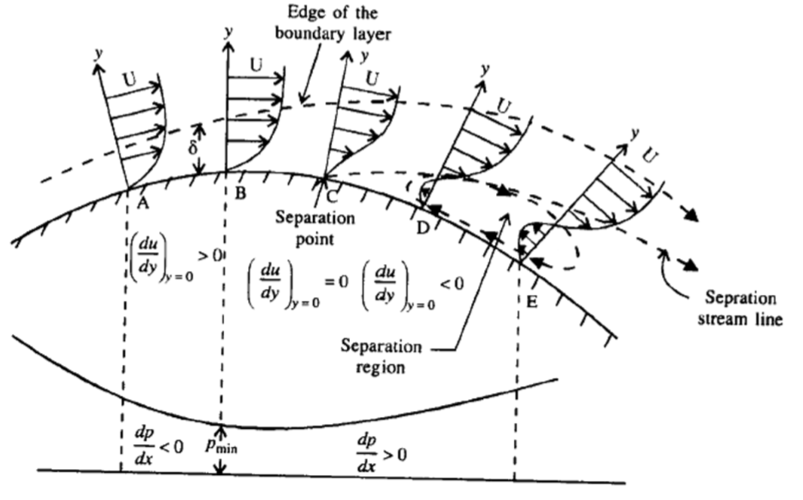
Factor influencing BL separation,
- Curvature of the surface.  - $Re$ | - Roughness (TBL) or Smoothness (LBL) of the surface.  - Turbulent flow has lesser boundary layer separation.

